**NAVIE BAYES LEARNING**

**CSE 303: Machine Learning**

Submitted by

Name: Ridhi Guntur

Roll No: AP22110011467

Section: CSE M

Lab Date: 29/10/2024

Submission Date: 04/11/2024

**Department Computer Science and Engineering**

**School of Engineering and Sciences**

**SRM University–AP**

**Amaravati, Andhra Pradesh – 522 240, India**

1. **Algorithm Description**

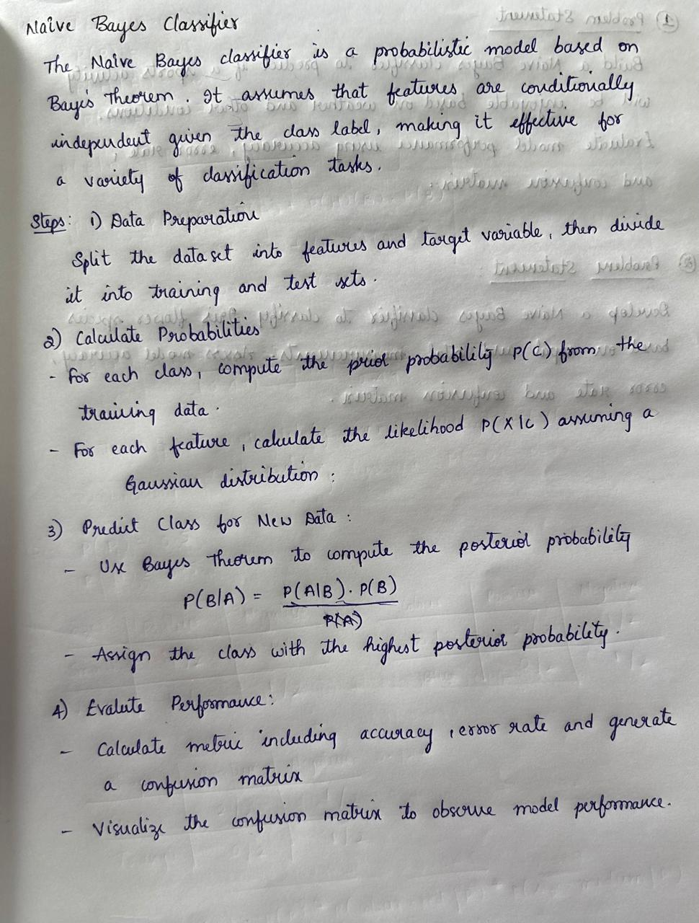

1. **Solution**

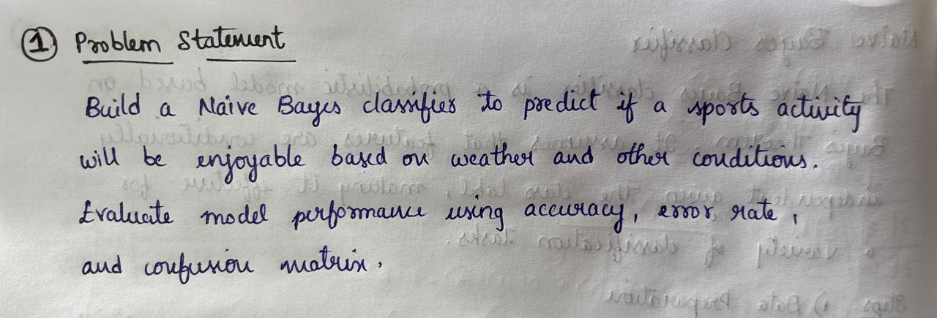

|  |
| --- |
| # Importing necessary libraries  from sklearn.model_selection import train_test_split  from sklearn.preprocessing import LabelEncoder  from sklearn.naive_bayes import GaussianNB  from sklearn.metrics import accuracy_score, confusion_matrix, classification_report  import pandas as pd  import seaborn as sns  import matplotlib.pyplot as plt  # Load dataset  data = pd.read_csv(r"C:\Users\guntu\Downloads\Enjoy sports.csv")  # Drop 'Day' column, as it is not a feature  data = data.drop(columns=['Day'])  # Encode categorical variables  le = LabelEncoder()  for column in data.columns:  data[column] = le.fit_transform(data[column])  # Split dataset into features (X) and target (y)  X = data.drop(columns=['Decision'])  y = data['Decision']  # Split data into training and test sets (70% train, 30% test)  X_train, X_test, y_train, y_test = train_test_split(X, y, test_size=0.3, random_state=42)  # Initialize and train Naive Bayes model  nb_model = GaussianNB()  nb_model.fit(X_train, y_train)  # Predict test set results  y_pred = nb_model.predict(X_test)  conf_matrix = confusion_matrix(y_test, y_pred)  print("Confusion Matrix:\n", conf_matrix)  plt.figure(figsize=(6, 4))  sns.heatmap(conf_matrix, annot=True, fmt='d', cmap='Blues', xticklabels=['Predicted No', 'Predicted Yes'], yticklabels=['Actual No', 'Actual Yes'])  plt.xlabel('Predicted')  plt.ylabel('Actual')  plt.title('Confusion Matrix Heatmap')  plt.show()  accuracy = accuracy_score(y_test, y_pred)  print("Accuracy:", accuracy)  error_rate = 1 - accuracy  print("Error Rate:", error_rate) |

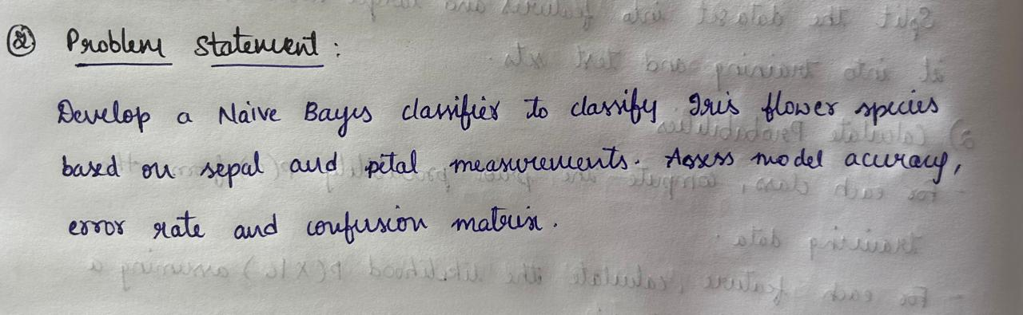

|  |
| --- |
| # Import necessary libraries  import pandas as pd  from sklearn.model_selection import train_test_split  from sklearn.naive_bayes import GaussianNB  from sklearn.metrics import accuracy_score, confusion_matrix, classification_report  import seaborn as sns  import matplotlib.pyplot as plt  # Load the iris dataset  data = pd.read_csv(r"C:\Users\guntu\Downloads\iris.csv" )  # Display the first few rows (optional)  print(data.head())  # Assuming the Iris dataset has features in columns 1-4 and target in the last column  X = data.iloc[:, :-1] # Features  y = data.iloc[:, -1] # Target  # Split data into training and test sets (70% train, 30% test)  X_train, X_test, y_train, y_test = train_test_split(X, y, test_size=0.3, random_state=42)  # Initialize and train the Naive Bayes model  nb_model = GaussianNB()  nb_model.fit(X_train, y_train)  # Predict test set results  y_pred = nb_model.predict(X_test)  # Display confusion matrix  conf_matrix = confusion_matrix(y_test, y_pred)  print("Confusion Matrix:\n", conf_matrix)  plt.figure(figsize=(6, 4))  sns.heatmap(conf_matrix, annot=True, fmt='d', cmap='Blues', xticklabels=nb_model.classes_, yticklabels=nb_model.classes_)  plt.xlabel('Predicted')  plt.ylabel('Actual')  plt.title('Confusion Matrix Heatmap')  plt.show()  accuracy = accuracy_score(y_test, y_pred)  print("Accuracy:", accuracy)  error_rate = 1 - accuracy  print("Error Rate:", error_rate) |

1. **Code Repository:**

GitHub link : <https://github.com/Ridhi-215/Navie_Bayes>